NextGen Tech
- Muhammad Abdullah 22-NTU-CS-1358
- Maryam Sameen 22-NTU-CS-1354
- Muhammad Kaif 22-NTU-CS-1364

Department of Computer Science, Faisalabad
BS-AI 6th
Submitted To: Mr. Zahid Javed

1. Problem Statement
NextGen Tech is a lightweight admin dashboard designed for a tech startup. It enables administrators to efficiently manage content in two core areas: blog posts and contact entries. Built using Next.js, Tailwind CSS, and TypeScript, the application provides a responsive and modern interface for performing CRUD (Create, Read, Update, Delete) operations on both data types.

2. Screenshots

Figure 1:Home Page
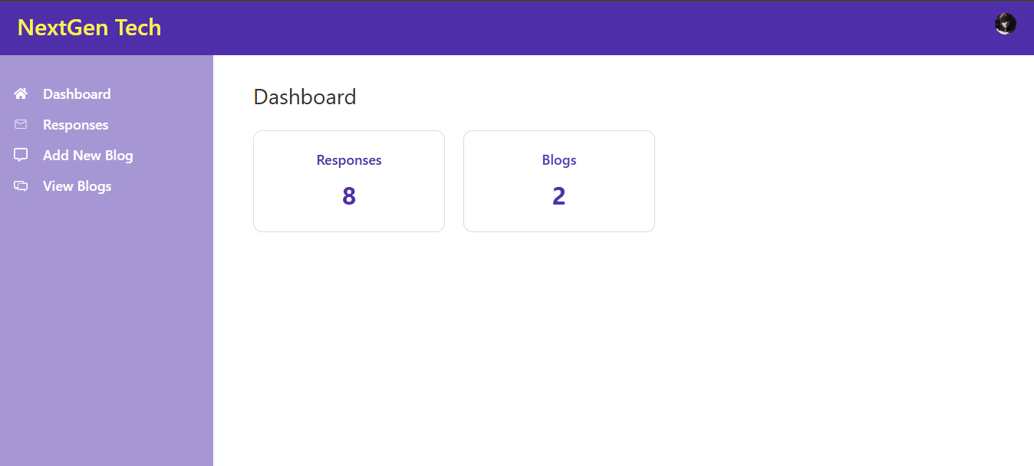
Figure 2:Admin Panel

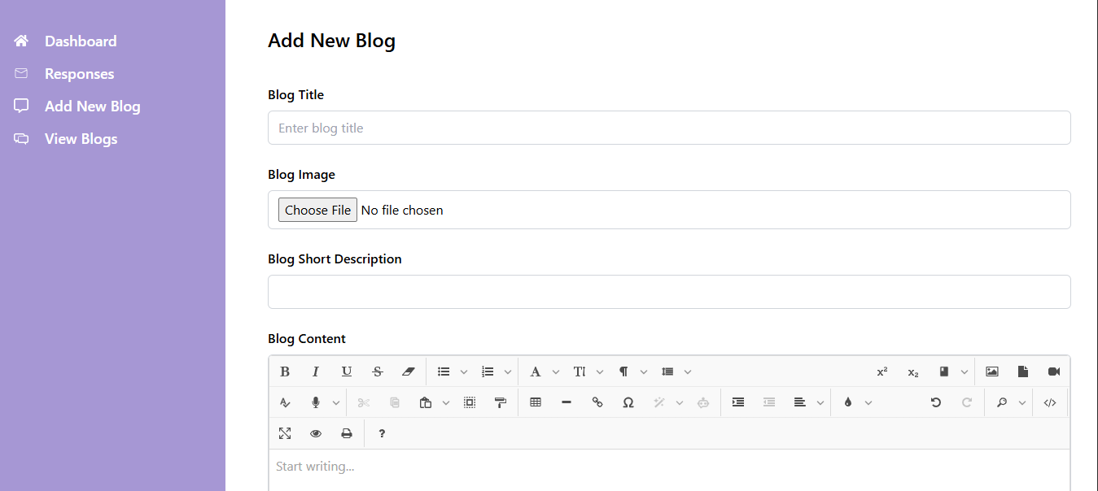
Figure 3:Add New Blog
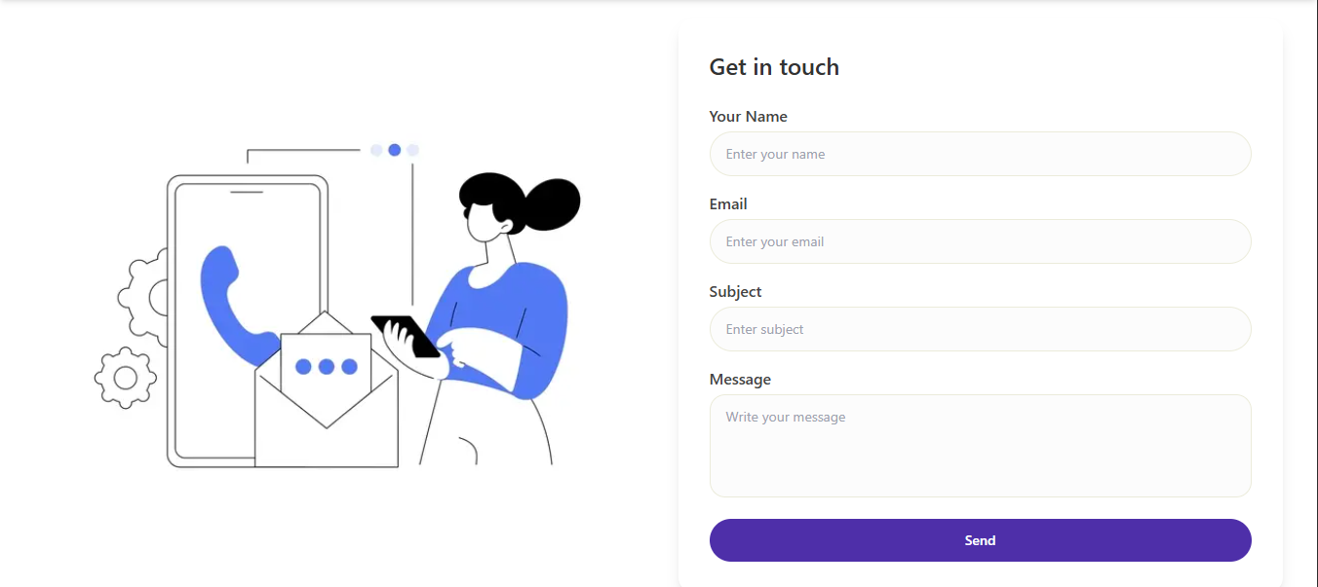
Figure 4:Contact Form

3. Code Sections

app/page.tsx
// import { BrowserRouter as Router, Routes, Route } from 'react-router-dom';
"use client"
import HeroCarousel from "./components/HeroCarousel";
import StatusCards from "./components/StatusCards";
import LoginComp from "./components/LoginComp";
import Footer from "./components/Footer";
import Header from "./components/Header";
import Services from "./components/Services";
import Blogs from "./components/Blogs";
import AboutUs from "./components/AboutUs";
import ContactUs from "./components/ContactUs"
import { useUser } from "@clerk/nextjs";
export default function App() {
const {user} = useUser();
console.log("user", user);
return (
<div className="home-page-wrapper">
<Header user={user}/>
<HeroCarousel />
<StatusCards />
<LoginComp />
<Blogs />
<Services />
<AboutUs />
<ContactUs />
<Footer />
</div>
);
}

app/layout.tsx
import type { Metadata } from "next";
import localFont from "next/font/local";
import "./globals.css";
import { ClerkProvider } from "@clerk/nextjs";
import { ToastContainer } from "react-toastify";
const geistSans = localFont({
src: "./fonts/GeistVF.woff",
variable: "--font-geist-sans",
weight: "100 900",
});
const geistMono = localFont({
src: "./fonts/GeistMonoVF.woff",
variable: "--font-geist-mono",
weight: "100 900",
});
export const metadata: Metadata = {
title: "Tech Startup",
description: " Tech Startup",
};
export default function RootLayout({
children,
}: Readonly<{
children: React.ReactNode;
}>) {
return (
<ClerkProvider>
<html lang="en">
<body className={`${geistSans.variable} ${geistMono.variable}`}>
<ToastContainer />
{children}
</body>
</html>
</ClerkProvider>
);
}

app/admin-panel/page.tsx
"use client";
import { useRouter } from "next/navigation";
import { useEffect, useState } from "react";
export default function Page() {
const router = useRouter();
const [data, setData] = useState<any>(false);
useEffect(() => {
const fetchData = async () => {
const data = await fetch("/api/dashboard-data", {
cache: "no-store",
});
const res = await data.json();
setData(res);
};
fetchData();
}, []);
const cards = [
{
title: "Responses",
count: data?.messagesCount || 0, // Replace with dynamic value later
route: "/admin-panel/messages",
},
{
title: "Blogs",
count: data?.blogsCount || 0, // Replace with dynamic value later
route: "/admin-panel/blogs",
},
];
return (
<div className="p-8 w-full max-w-full">
<h1 className="text-[28px] mb-6 text-[#333]">Dashboard</h1>
<div className="flex flex-wrap gap-6">
{cards.map((card, index) => (
<div

app/admin-panel/add-blog/page.tsx
import Spinner from "@/app/components/Spinner";
import dynamic from "next/dynamic";
import { Suspense } from "react";
const AddBlogForm = dynamic(
() => import("../../components/Adminpanel/AddBlogForm"),
{
ssr: false,
}
);
export default function Page() {
return (
<Suspense fallback={<Spinner />}>
<AddBlogForm />
</Suspense>
);
}

database.ts
import mongoose from "mongoose";
const connectDatabase = async () => {
const uri = process.env.MONGODB_URI
try {
if (!uri) {
throw new Error('MONGODB_URI environment variable is not defined');
}
await mongoose.connect(uri);
console.log("Databse Connected Successfully.");
} catch (error) {
console.log(error);
}
};
export default connectDatabase;

App/Components/Adminpanel/Addblogform.tsx
"use client";
import { useFormik } from "formik";
import { useRouter, useSearchParams } from "next/navigation";
import { Suspense, useEffect, useRef, useState } from "react";
import { toast } from "react-toastify";
import * as Yup from "yup";
import dynamic from "next/dynamic";
import Spinner from "../Spinner";
const JoditEditor = dynamic(() => import("jodit-react"), {
ssr: false,
});
export default function Page() {
const editor = useRef(null);
const id = useSearchParams().get("id");
const [blog, setBlog] = useState<any>(null);
const router = useRouter();
const [loading, setLoading] = useState(false);
const validationSchema = Yup.object({
title: Yup.string().required("Title is required"),
shortDescription: Yup.string()
.required("Short Description is required")
.max(60, "Description can be max 60 characters"),
content: Yup.string().required("Content is required"),
});
useEffect(() => {
if (id) {
const fetchBlog = async () => {
const res = await fetch(`/api/blogs/${id}`);
const data = await res.json();
setBlog(data);
};
fetchBlog();
}
}, [id]);
const handleSubmit = async () => {
const { title, image, content, shortDescription } = formik.values;
const formData = new FormData();
formData.append("title", title);
if (image instanceof File) {
formData.append("image", image);
} else if (id && blog?.image) {
formData.append("existingImage", blog.image);
}
formData.append("description", content);
formData.append("shortDescription", shortDescription);
try {
setLoading(true);
const endpoint = id ? `/api/blogs/${id}` : "/api/blogs";
const response = await fetch(endpoint, {
method: id ? "PATCH" : "POST",
body: formData,
});
if (response?.ok) {
toast.success(`Blog ${id ? "updated" : "added"} successfully`);
formik.resetForm();
setLoading(false);
router.push("/admin-panel/blogs");
}
} catch (error) {
toast.error("Error uploading blog");
console.log("error", error);
}
};
const formik:any = useFormik({
initialValues: {
title: blog?.title || "",
image: null,
content: blog?.description || "",
shortDescription: blog?.shortDescription || "",
},
validationSchema,
onSubmit: handleSubmit,
enableReinitialize: true,
});
return (
<div className="p-8 w-full">
<div className="w-full">
<Suspense fallback={<Spinner />}>
<form onSubmit={formik.handleSubmit} className="flex flex-col gap-6">
<h2 className="text-2xl font-semibold mb-4">Add New Blog</h2>

<div className="flex flex-col">
<label htmlFor="title" className="font-medium mb-2">
Blog Title
</label>
<input
type="text"
id="title"
value={formik.values.title}
onChange={formik.handleChange}
name="title"
onBlur={formik.handleBlur}
placeholder="Enter blog title"
className="px-3 py-2 border border-gray-300 rounded-md text-black bg-white"
/>
{formik.touched.title && formik.errors.title && (
<p className="text-red-500 text-sm mt-1">
{formik.errors.title}
</p>
)}
</div>

<div className="flex flex-col">
<label htmlFor="image" className="font-medium mb-2">
Blog Image
</label>
<input
type="file"
id="image"
accept="image/*"
name="image"
onChange={(e: any) =>
formik.setFieldValue("image", e.target.files[0])
}
className="px-3 py-2 border border-gray-300 rounded-md bg-white"
/>
{formik.touched.image && formik.errors.image && (
<p className="text-red-500 text-sm mt-1">
{formik.errors.image}
</p>
)}
</div>

<div className="flex flex-col">
<label htmlFor="shortDescription" className="font-medium mb-2">
Blog Short Description
</label>
<input
type="text"
id="shortDescription"
name="shortDescription"
onChange={formik.handleChange}
onBlur={formik.handleBlur}
value={formik.values.shortDescription}
className="px-3 py-2 border border-gray-300 rounded-md text-black bg-white"
/>
{formik.touched.shortDescription &&
formik.errors.shortDescription && (
<p className="text-red-500 text-sm mt-1">
{formik.errors.shortDescription}
</p>
)}
</div>

<div className="flex flex-col">
<label className="font-medium mb-2">Blog Content</label>
<div className="border border-gray-300 rounded-md overflow-hidden">
<JoditEditor
ref={editor}
value={formik.values.content}
onChange={(newContent) =>
formik.setFieldValue("content", newContent)
}
/>
</div>
{formik.touched.content && formik.errors.content && (
<p className="text-red-500 text-sm mt-1">
{formik.errors.content}
</p>
)}
</div>
<button
type="submit"
className="px-6 py-3 bg-[#4e2fa9] text-white rounded-lg font-medium max-w-xs hover:bg-[#3c2390] transition duration-300"
>
{loading ? <Spinner /> : "Save Blog"}
</button>
</form>
</Suspense>
</div>
</div>
);
}

